**CS 634 Data Mining Project**

**Apriori Algorithm**

**Name – Tanish Bugnait**

**Date – 03/24/2021**

This project is a basic implementation of how the Apriori algorithm is used to generate all possible association rules provided we have a dataset in hand.

**Software Used**

* Jupyter Notebook
* Python 3.8

**Dataset Used for the project**

* Amazon
* K-Mart
* Nike
* BestBuy
* Custom Data (Social Media)
* Custom Data (Fruits)

**Hardware Configuration**

* Windows 10 (Home Edition)
* Core i7
* 8th Generation

The below screenshot shows the implementation of the Apriori algorithm:

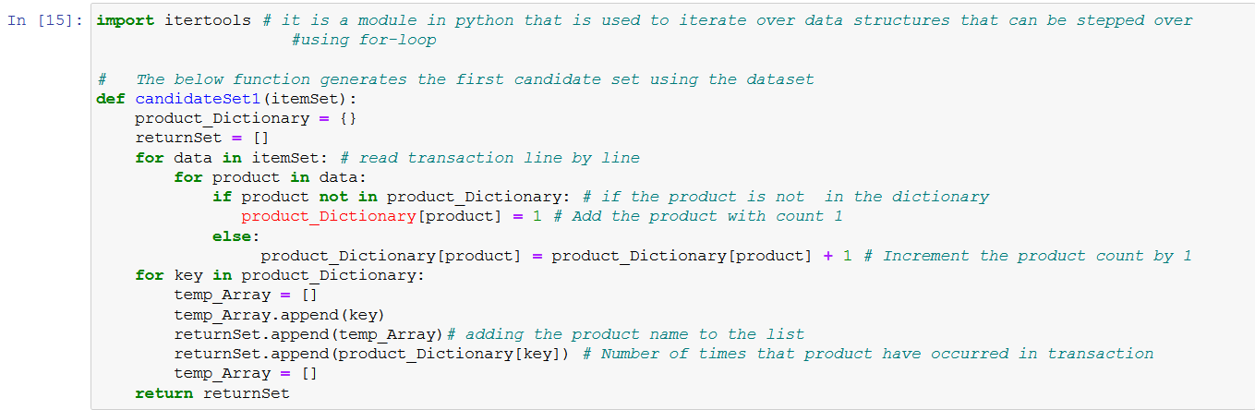

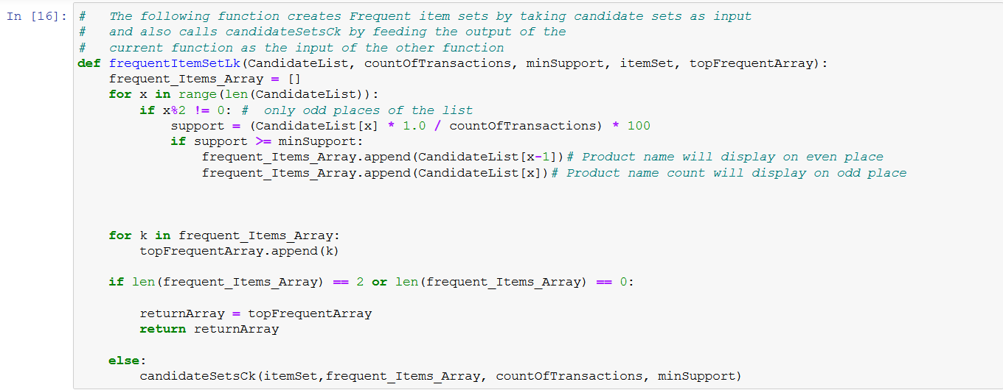

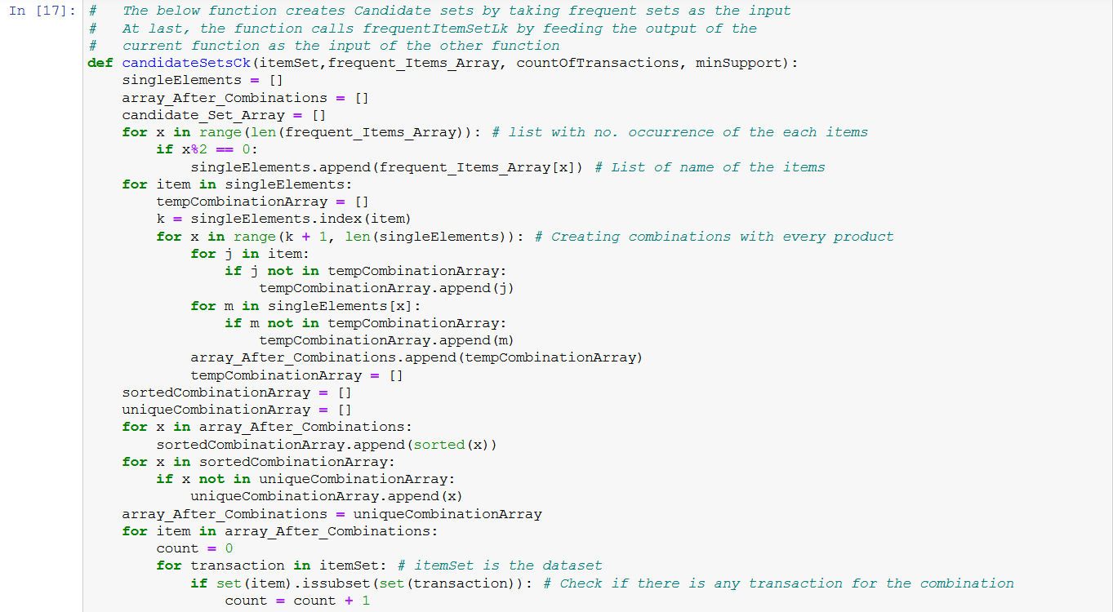



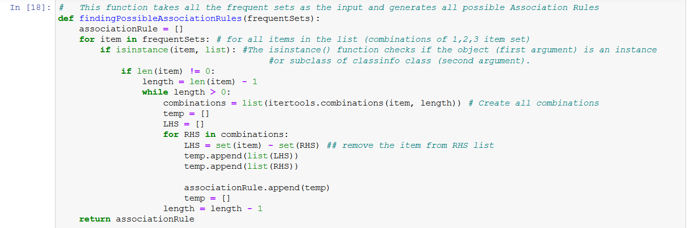

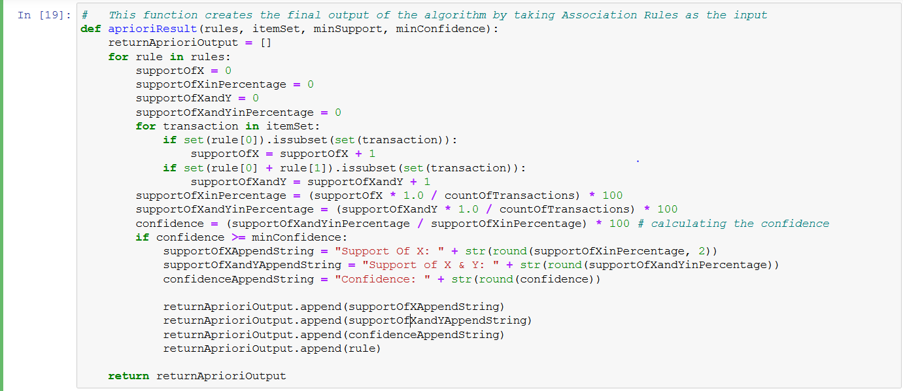

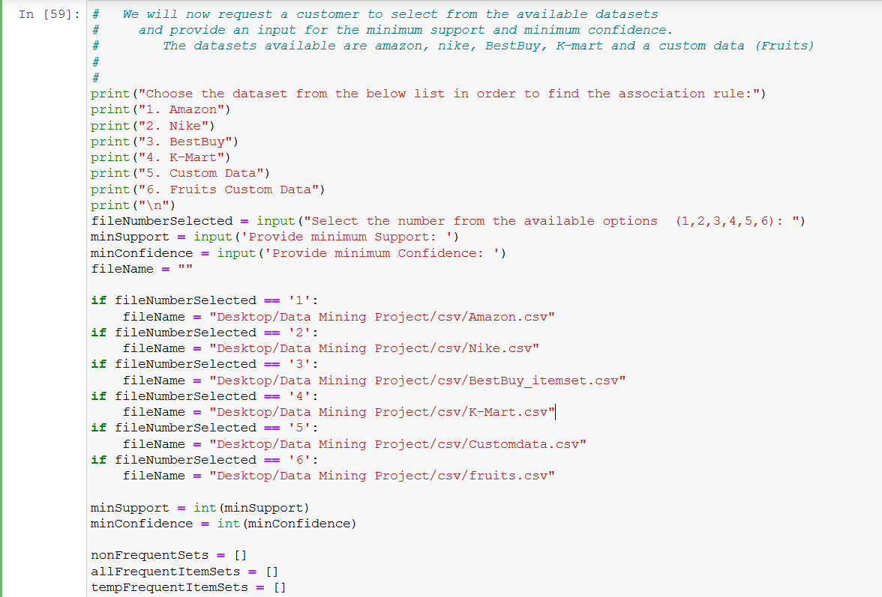

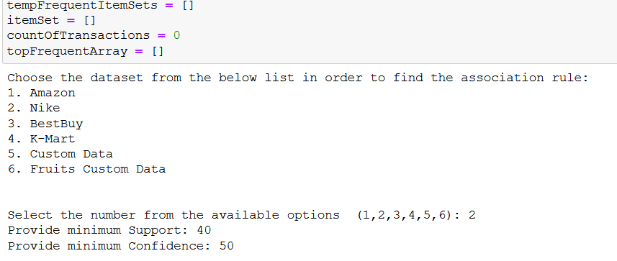

From the above screenshot we can see that the user has the option of selecting from the available datasets which are Amazon, Nike, BestBuy, K-Mart and a custom data (Social Media).

The program also provides an option where the user can input the values for minimum support and minimum confidence.

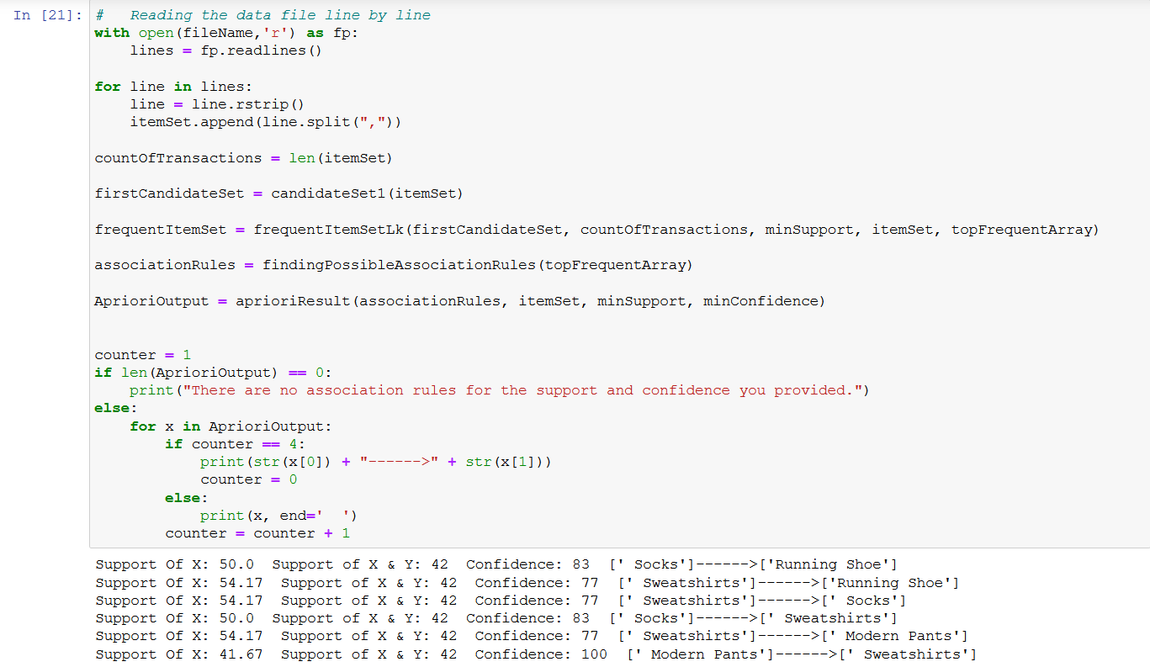

From the above screenshot we can see that once the user has provided a minimum support and confidence value, we get all possible association rules.

Let’s explore the association rules for each dataset with different combinations.

1. ***Amazon***

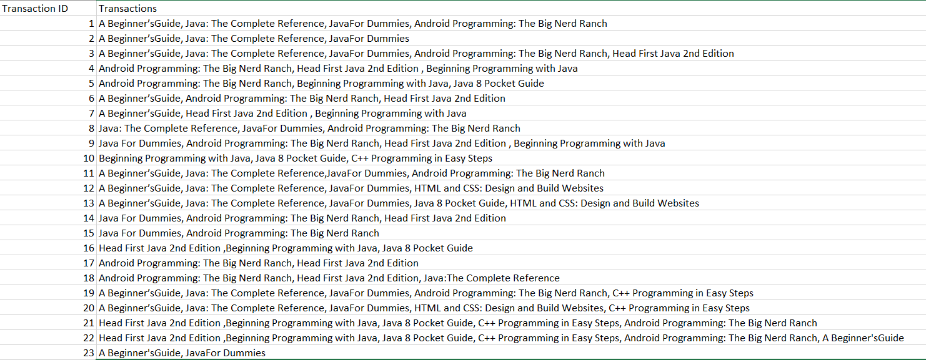

The above is the dataset for amazon I used. In the below screenshots we’ll see the association rules for this dataset by inserting different values for support and confidence.

1. Minimum Support = 32 and Minimum Confidence = 70

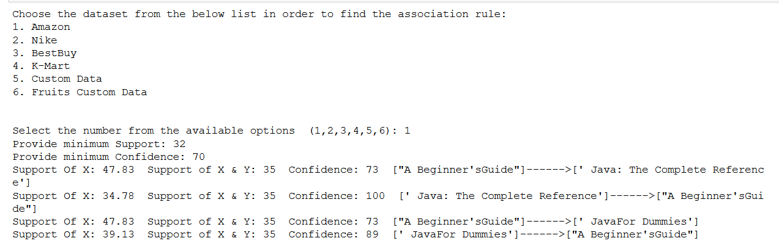

1. Minimum Support = 30 and Minimum Confidence = 60

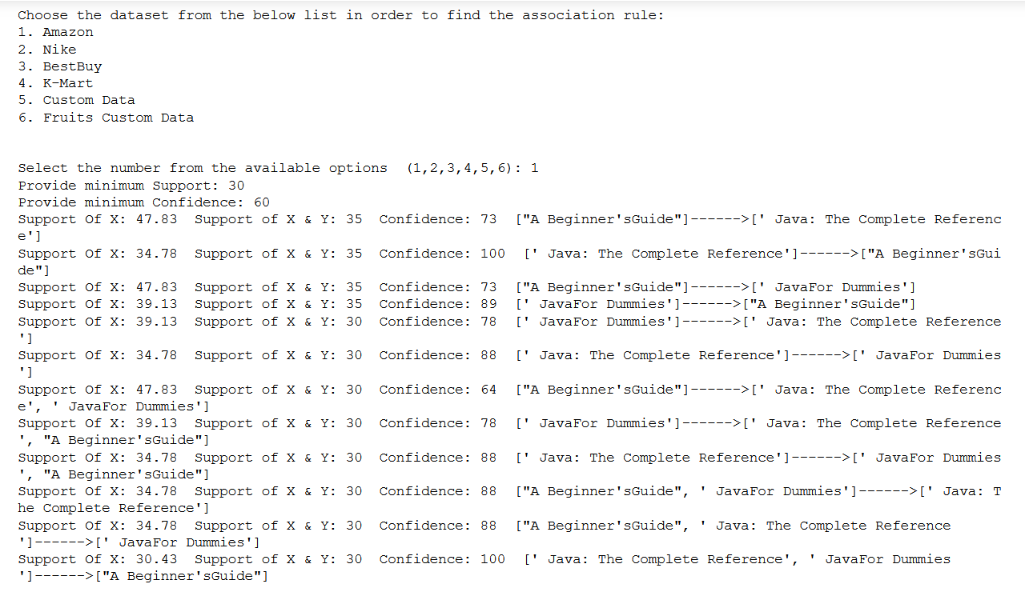

1. Minimum Support = 32 and Minimum Confidence = 85

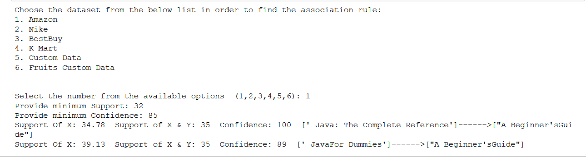

1. ***Nike***

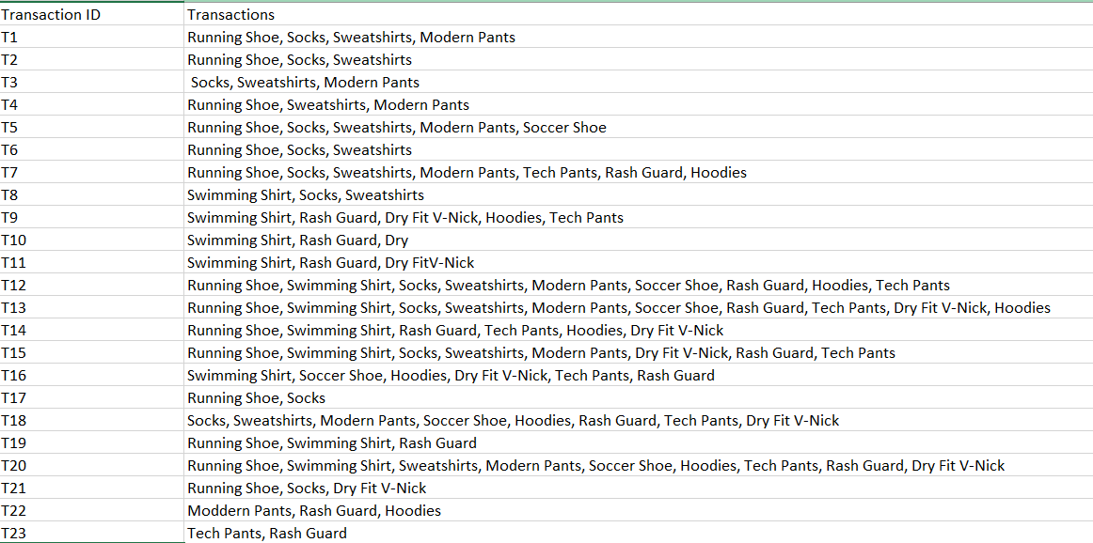

1. Minimum Support = 30 and Minimum Confidence = 45

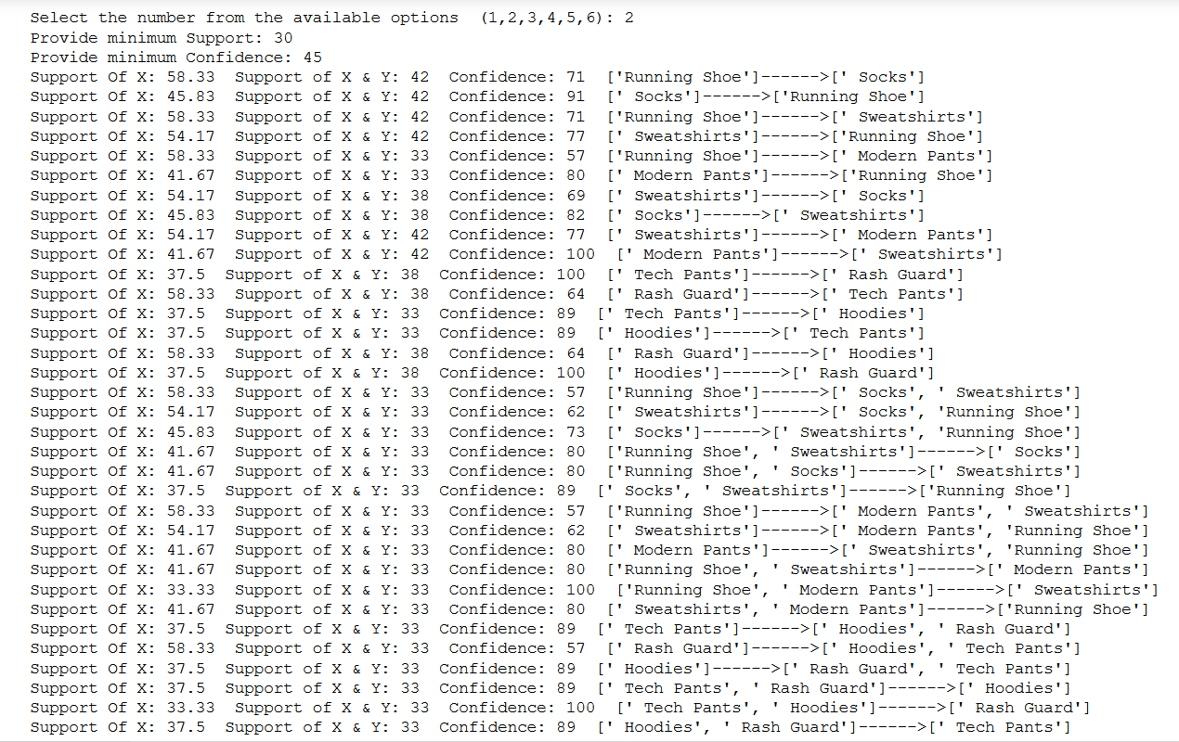

1. Minimum Support = 40 and Minimum Confidence = 50

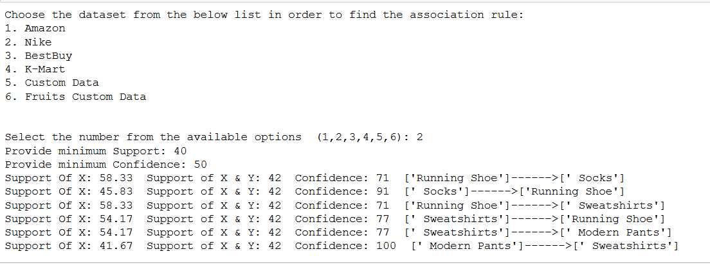

1. Minimum Support = 41 and Minimum Confidence = 75

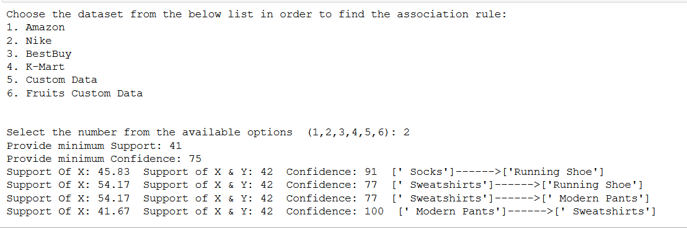

1. ***BestBuy***

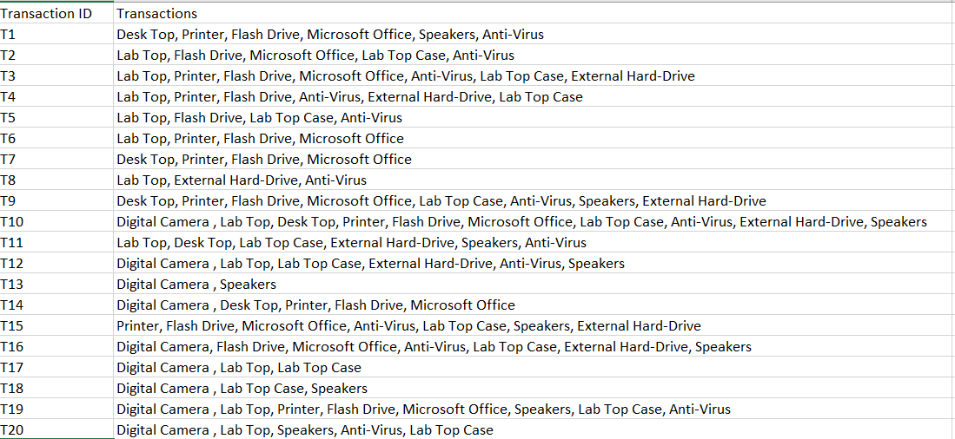

1. Minimum Support = 40 and Minimum Confidence = 65

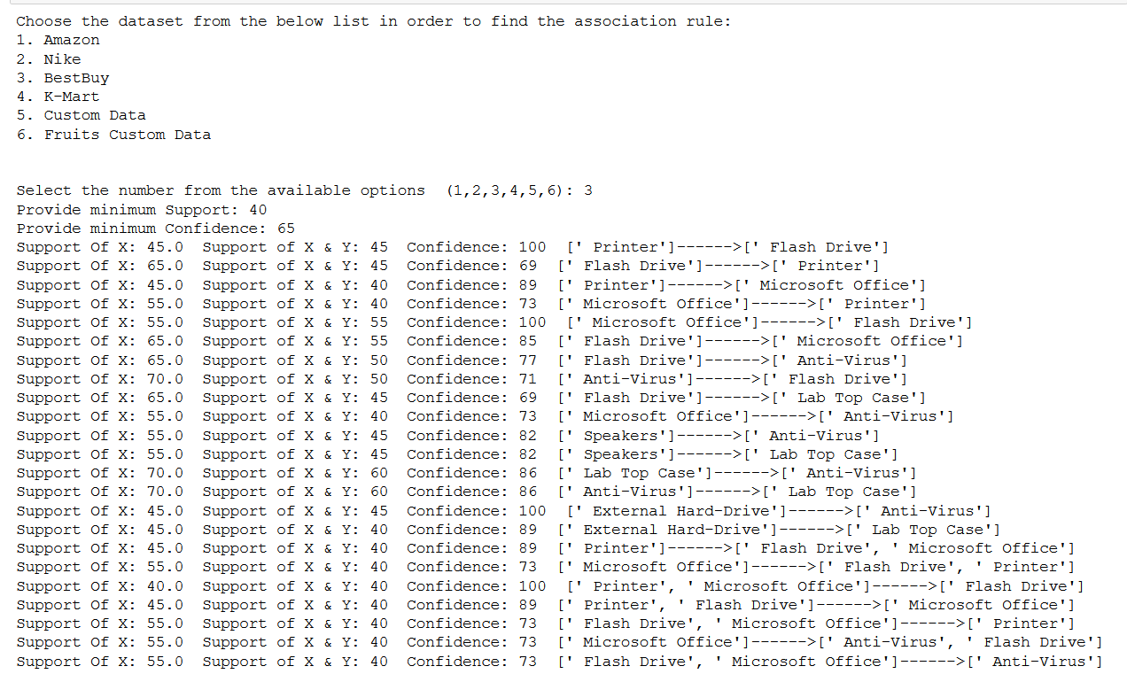

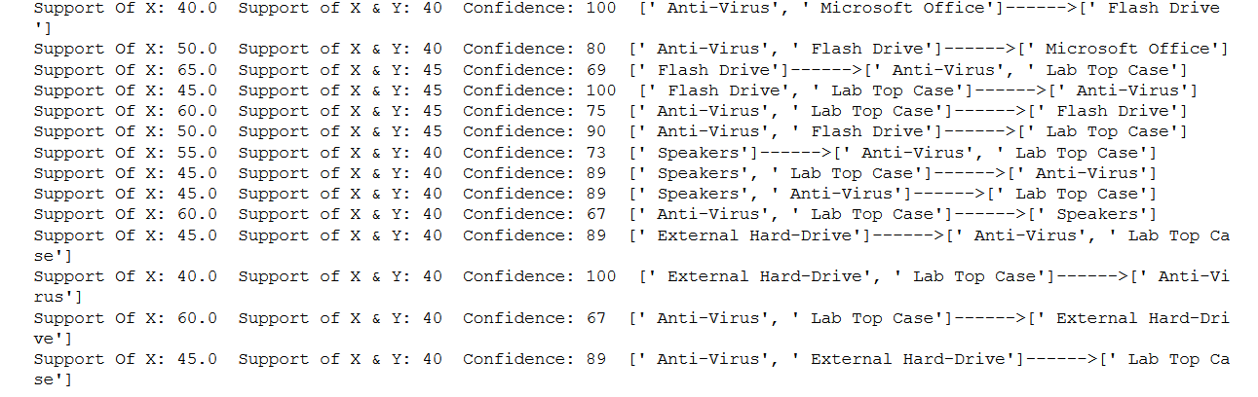

1. Minimum Support = 60 and Minimum Confidence = 85

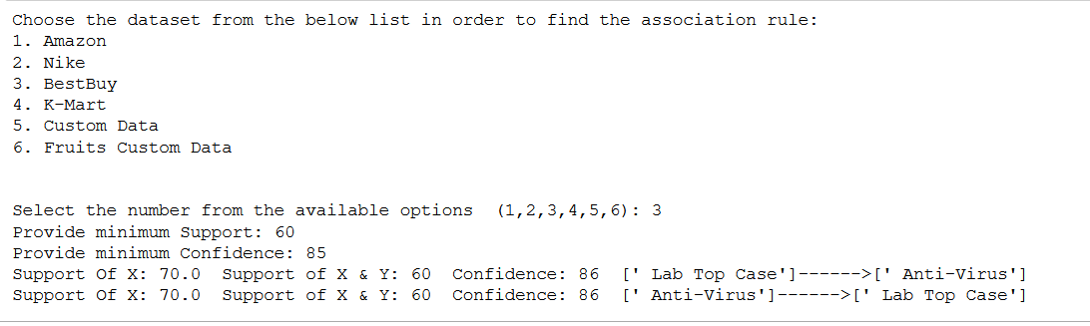

1. Minimum Support = 50 and Minimum Confidence = 70

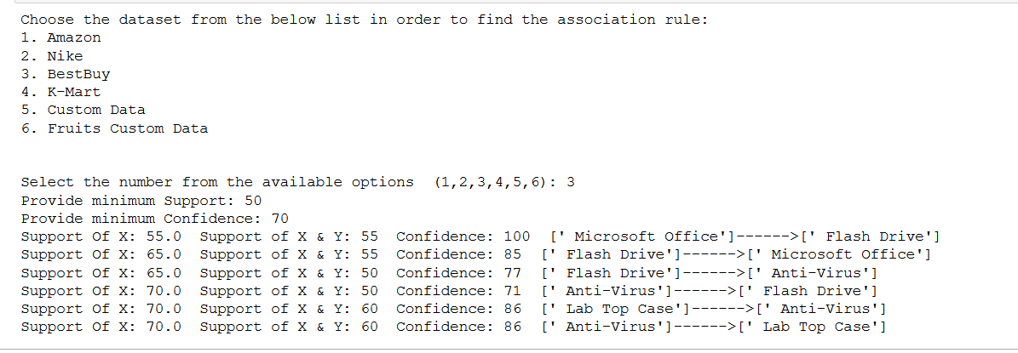

1. ***Custom Data (Social Media Apps)***

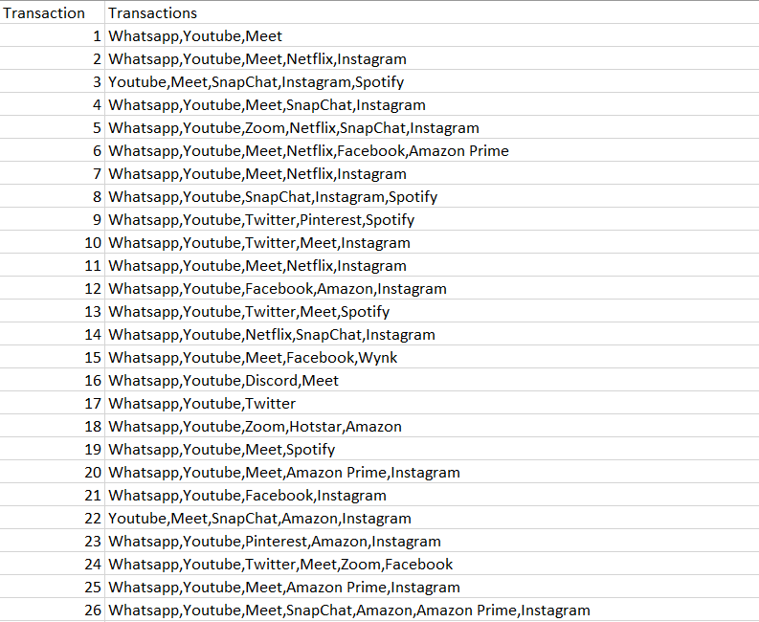



1. Minimum Support = 45 and Minimum Confidence = 55

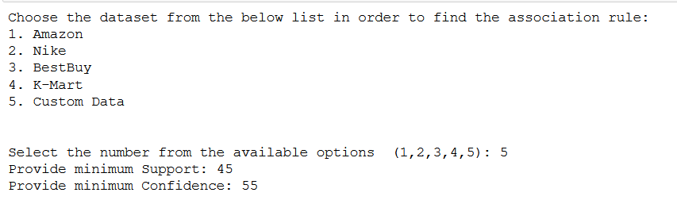

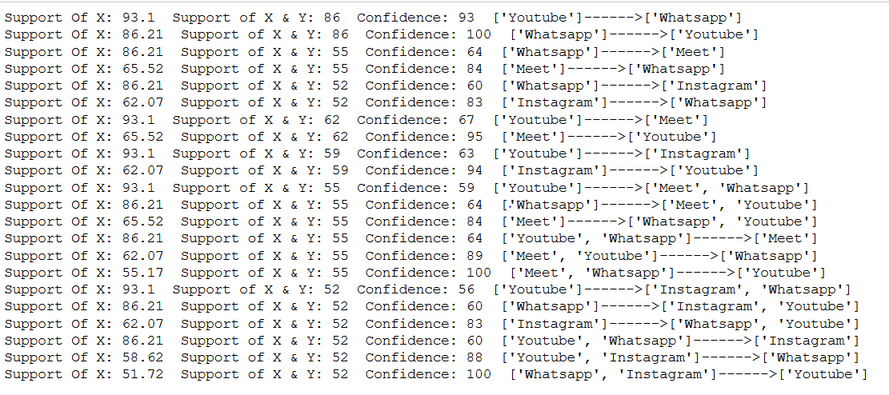

1. Minimum Support = 52 and Minimum Confidence = 62

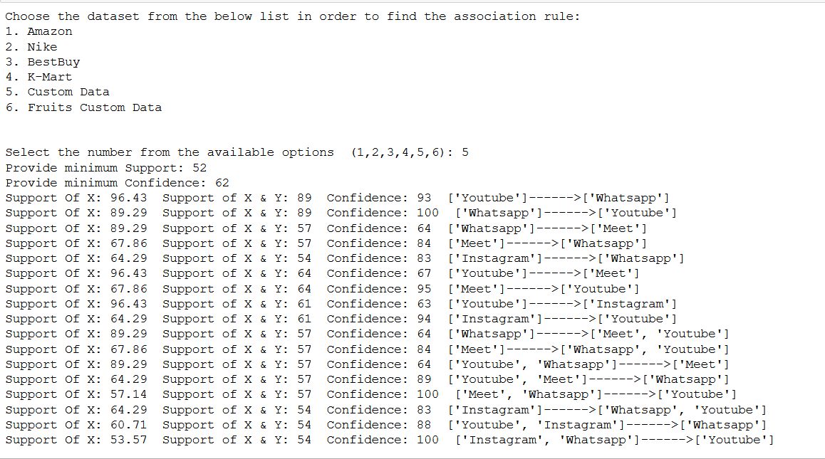

1. Minimum Support = 60 and Minimum Confidence = 65

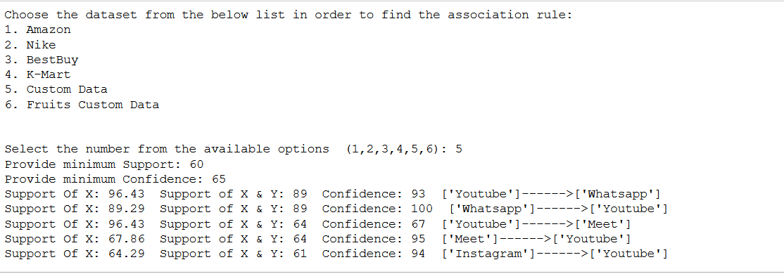

1. ***K-MART***

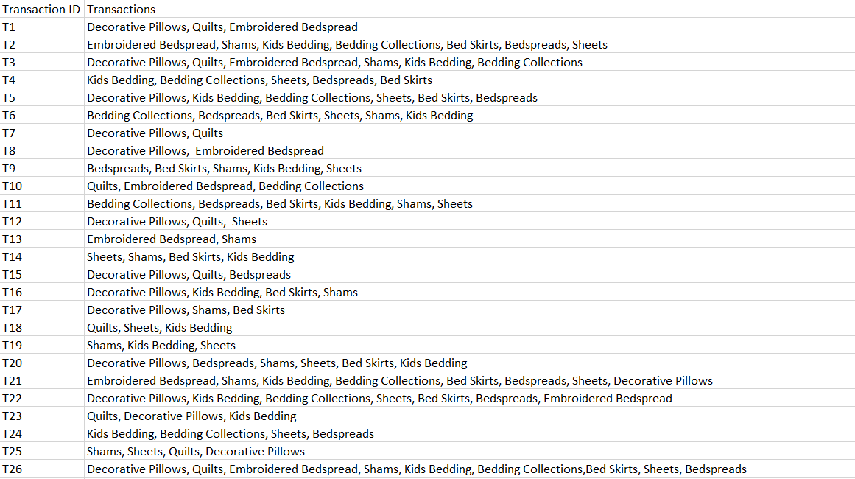



1. Minimum Support = 30 and Minimum Confidence = 50

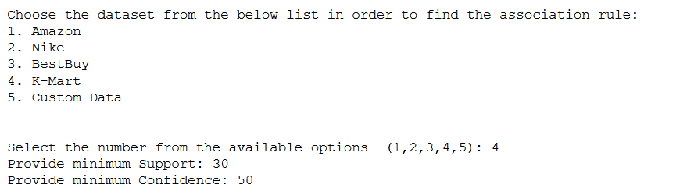

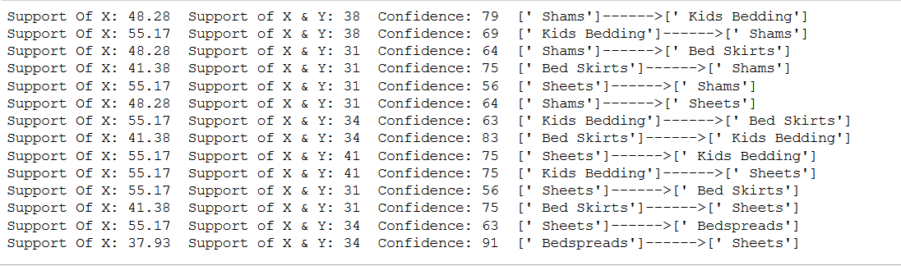

1. Minimum Support = 35 and Minimum Confidence = 65

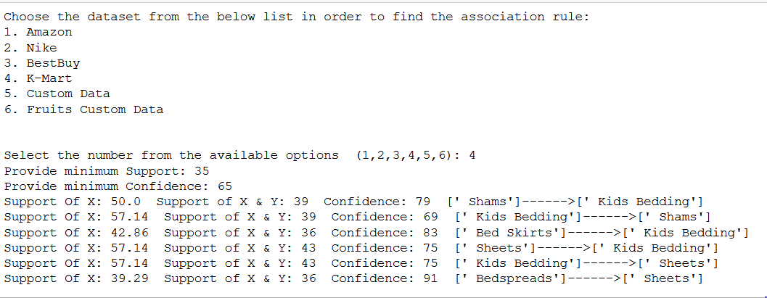

1. Minimum Support = 40 and Minimum Confidence = 70

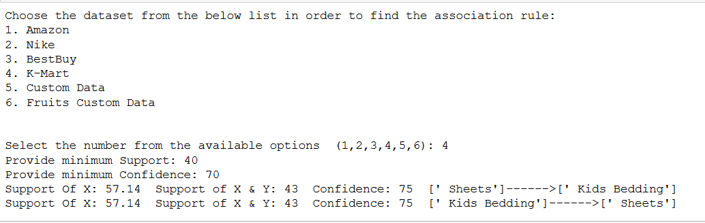

1. ***Fruits Custom Data***

* Minimum Support = 50 and Minimum Confidence = 70

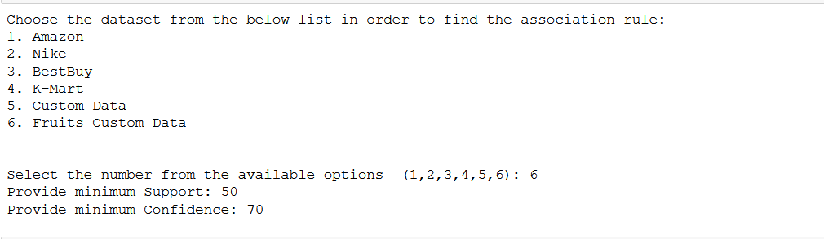

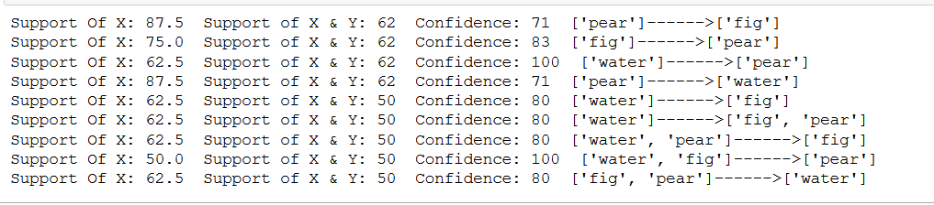

* Minimum Support = 55 and Minimum Confidence = 80

